**Name:- Mansi Kapri**

**COURSE:- Bsc(IT) V**

**ROLL NO. : - 1922033**

**UNIVERSITY ID :- 19052006**

**SUBJECT :- MOBILE APPLICATION DEVELOPMENT LAB**

**SUBJECT CODE:- PBI 501**

**MID TERM PRACTICAL**

**Problem Statement: Create a program to depict activity lifecycle.**

**Objective: To understand the function and functioning of an activity lifecycle.**

**XML FILE CODING:**

<?xml version="1.0" encoding="utf-8"?>  
<androidx.constraintlayout.widget.ConstraintLayout xmlns:android="http://schemas.android.com/apk/res/android"  
 xmlns:app="http://schemas.android.com/apk/res-auto"  
 xmlns:tools="http://schemas.android.com/tools"  
 android:layout_width="match_parent"  
 android:layout_height="match_parent"  
 tools:context=".MainActivity">  
  
 <EditText  
 android:id="@+id/editTextTextPersonName"  
 android:layout_width="wrap_content"  
 android:layout_height="wrap_content"  
 android:ems="10"  
 android:inputType="textPersonName"  
 android:text="Application lifecycle"  
 android:textStyle="bold"  
 app:layout_constraintBottom_toBottomOf="parent"  
 app:layout_constraintEnd_toEndOf="parent"  
 app:layout_constraintStart_toStartOf="parent"  
 app:layout_constraintTop_toTopOf="parent" />  
</androidx.constraintlayout.widget.ConstraintLayout>

**JAVA SOURCE CODE:**

package com.firstapp.lifecycle;  
  
import androidx.appcompat.app.AppCompatActivity;  
  
import android.os.Bundle;  
import android.util.Log;  
  
public class MainActivity extends AppCompatActivity {  
  
 @Override  
 protected void onCreate(Bundle savedInstanceState) {  
 super.onCreate(savedInstanceState);  
 setContentView(R.layout.*activity_main*);  
  
 Log.*d*("Lifecycycle","onCreate Invoke");  
 }  
 public void onStart(){  
 super.onStart();  
 Log.*d*("LifeCycle","onStart Invoke");  
  
 }  
  
  
 public void onResume(){  
 super.onResume();  
 Log.*d*("LifeCycle","onResume Invoke");  
  
 }  
  
  
 public void onPause(){  
 super.onPause();  
 Log.*d*("LifeCycle","onPause Invoke");  
  
 }  
  
  
 public void onStop(){  
 super.onStop();  
 Log.*d*("LifeCycle","onStop Invoke");  
  
 }  
  
 public void onDestroy(){  
 super.onDestroy();  
 Log.*d*("LifeCycle","onDestroy Invoke");  
  
 }  
  
}

**OUTPUT:-**

**OUTPUT WHEN LAUNCHING AN ACTIVITY onCreate(), onStart(), onResume() has invoked:**

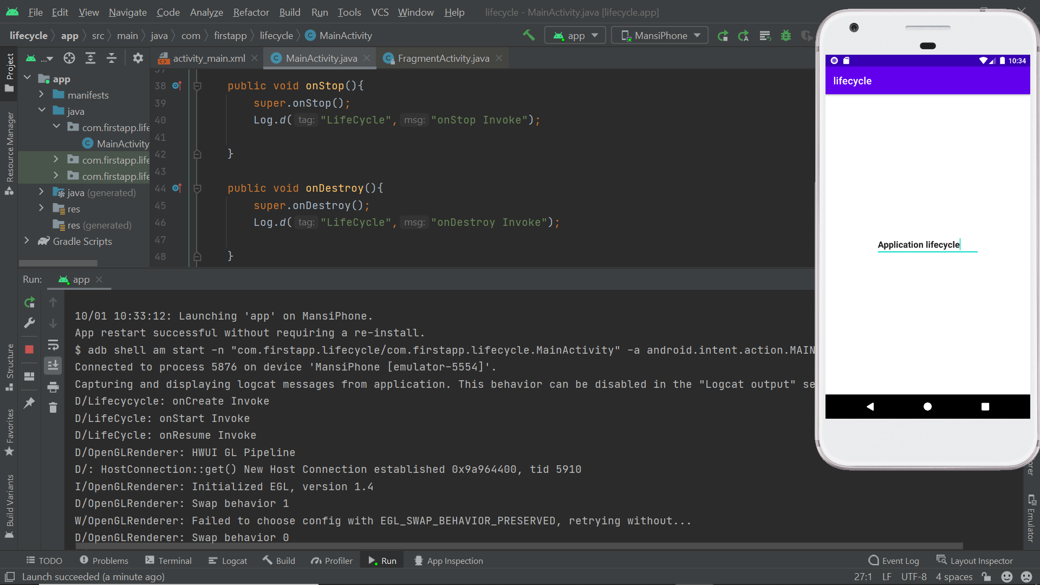

**OUTPUT :-**

**when we come out from the ACTIVITY onStop() , onDestroyed() has invoked:**

